✅ DOM Concepts — Full Interview Prep

1. What is the DOM?
- DOM = Document Object Model
- A tree-like representation of an HTML document.
- Browser converts HTML → DOM so JavaScript can interact with the page.

Key points:
- DOM is a programming interface, not the HTML file itself.
- It's language-agnostic but mostly used with JavaScript.
- DOM updates reflect immediately in the rendered UI.

2. DOM Tree Structure
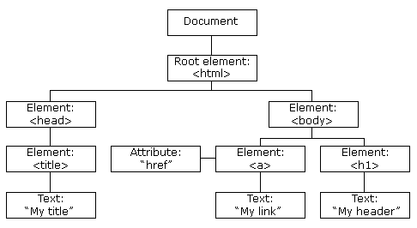

- Document
  - <html>
    - <head>
    - <body>
      - Elements
      - Text Nodes
      - Comments

Node Types:
- 1 → Element
- 3 → Text
- 8 → Comment
- 9 → Document
- 11 → DocumentFragment

3. Selecting Elements

Older methods:
- getElementById()
- getElementsByClassName()
- getElementsByTagName()

Modern methods:
- querySelector()
- querySelectorAll()
const btn = document.querySelector('.btn');
const items = document.querySelectorAll('.item');
Tip: querySelectorAll returns a NodeList, not an array.

4. DOM Nodes vs. Elements
- Node → generic term (can be comment, text, element)
- Element → node with tag (like <div>)
Element ⊂ Node

5. DOM Traversal

Parent / Child:
element.parentElement
element.children
element.firstElementChild
element.lastElementChild

Siblings:
element.nextElementSibling
element.previousElementSibling

6. Modifying Elements

Change text:
element.textContent = "Hello";
element.innerHTML = "<b>Hello</b>";

Change attributes:
element.setAttribute('id', 'header');
element.getAttribute('src');

Change styles:
element.style.color = "red";

7. Creating & Removing Elements

Create:
const div = document.createElement('div');
div.textContent = "Hello";
document.body.appendChild(div);

Remove:
element.remove();
parent.removeChild(child);

8. DOM Events
- Click
- Input
- Change
- Submit
- Load
- Keydown / keyup
- Mouseover / mouseout

Add listener:
element.addEventListener("click", function() {});

9. Event Object
Automatically passed to handlers:
button.addEventListener("click", (e) => {
console.log(e.target);
});

10. Event Bubbling & Capturing
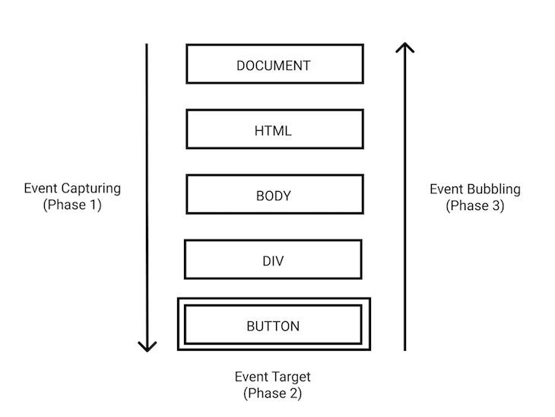

Bubbling (default):
Event goes child → parent

Capturing:
Event goes parent → child
element.addEventListener("click", handler, true); // capturing

11. Event Delegation
Attach event to parent instead of multiple children.
list.addEventListener("click", (e) => {
if (e.target.matches(".item")) {
console.log("Item clicked");
}
});

Why useful?
- Better performance
- Handles dynamically added elements

12. DOM Manipulation Performance

Expensive operations:
- frequent layout/reflow
- modifying style multiple times

Optimizations:
- Use DocumentFragment
- batch DOM updates
- use CSS classes instead of inline style changes

13. DocumentFragment
Lightweight container that doesn't trigger reflow.
const frag = document.createDocumentFragment();
for(let i=0; i<1000; i++){
let li = document.createElement("li");
frag.appendChild(li);
}
ul.appendChild(frag);

14. InnerHTML vs TextContent vs InnerText
Method | Reads HTML? | Renders HTML? | Performance
innerHTML | Yes | Yes | Slow
textContent | No | No | Fast
innerText | No | No (layout-based) | Slowest

15. DOM Reflow & Repaint

Reflow → layout changes

Repaint → visual changes without layout change
Avoid forced reflow:
element.offsetHeight; // forces reflow!

16. DOMContentLoaded vs Load
Event | When Fired
DOMContentLoaded | After HTML parsed
load | After entire page loaded (images, CSS, etc.)

17. Shadow DOM / Web Components
- Provides encapsulation
- Styles do not leak in or out
- Part of Web Components spec
const shadow = element.attachShadow({ mode: "open" });

🎯 Top DOM Interview Questions (with answers)

1. What is the DOM?
➝ A tree representation of HTML that JavaScript can manipulate.

2. Difference between NodeList and HTMLCollection?
- NodeList: can contain any nodes (text, comment)
- HTMLCollection: elements only
- NodeList is not live (except old childNodes)
- HTMLCollection is live

3. How does event bubbling work?
➝ Event starts at the deepest element and bubbles up to parents.

4. What is event delegation and why use it?
➝ Use a single listener on a parent to handle events from multiple child elements.
Benefits:
- Better performance
- Supports dynamic DOM updates

5. Why is innerHTML considered unsafe?
➝ Vulnerable to XSS attacks.

6. Difference between innerHTML and textContent?
(innerHTML parses HTML; textContent outputs plain text)

7. What causes DOM reflow?
- Changing size/position
- Changing fonts
- Adding/removing nodes

8. What is a DocumentFragment?
➝ A lightweight DOM container used to batch operations without reflow.

9. How to prevent event bubbling?
event.stopPropagation();

10. What is Shadow DOM?
➝ Browser-native encapsulation for UI components.

11. Why is direct DOM manipulation slow?
➝ Because it triggers layout & repaint operations.

12. Difference between DOMContentLoaded and Load event?
- DOMContentLoaded: HTML parsed
- Load: everything loaded

13. What is the difference between attribute and property?
- attribute: HTML
- property: JS representation (dynamic)

14. How do you clone a node?
element.cloneNode(true);

15. How to add element before another?
parent.insertBefore(newElement, referenceElement);

